***Japanese Food: Sushi***

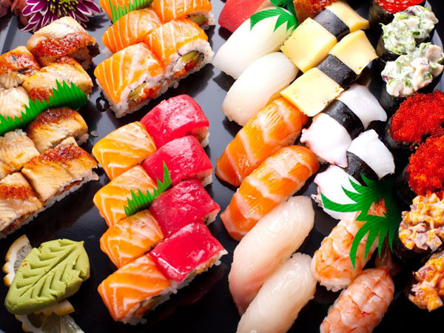

**Present by: Xin Shen**

**Date: 2016 fall semester**

**Inspector: Prof. Lawrence**

**History of sushi in the U.S.A**

Sushi was first served in the United States in the early 1900s following an influx of Japanese immigration after the [Meiji Restoration](https://en.wikipedia.org/wiki/Meiji_Restoration). A wave of [Japanophilia](https://en.wikipedia.org/wiki/Japanophilia) in American [high society](https://en.wikipedia.org/wiki/High_society_(social_class)) resulted in the serving of sushi at social functions.  The first American sushi restaurants appeared in the early 1960s, most notably in major metropolitan areas of Los Angeles and New York City. The Kawafuku restaurant in the [Little Tokyo](https://en.wikipedia.org/wiki/Little_Tokyo,_Los_Angeles) neighborhood of Los Angeles, founded in 1966 by Noritoshi Kanai and Harry Wolff, is credited as the first American restaurant "to commercially transport large amounts of fish from Japan, for the purpose of making sushi, on a regular basis."

**The reason for people choose sushi**

* **Why is sushi good for your health?**

On average, the Japanese diet - raw fish, vegetables, and rice - contains only 30pc fat, most of it the healthier polyunsaturated variety, compared with 40pc in Britain.

As a result, their rates of heart disease are among the lowest in the world. Recently, scientists in Japan found that sushi dishes - flavored parcels of rice with raw fish and vegetables - could even protect smokers against lung cancer.

* **What are the health benefits of sushi?**
* Sushi is a quick and easy source of protein
* The omega-3 fatty acids found in fish benefit your cardiovascular health
* natural anti-inflammatory compounds and play a role in brain function
* **Why is sushi so popular in the U.S?**
* **Convenient to eat**
* **Fairly healthy food**
* **Tasty**
* **Variety**
* **Exotic food**
* **Status symbol**

**Personal experience in making sushi**

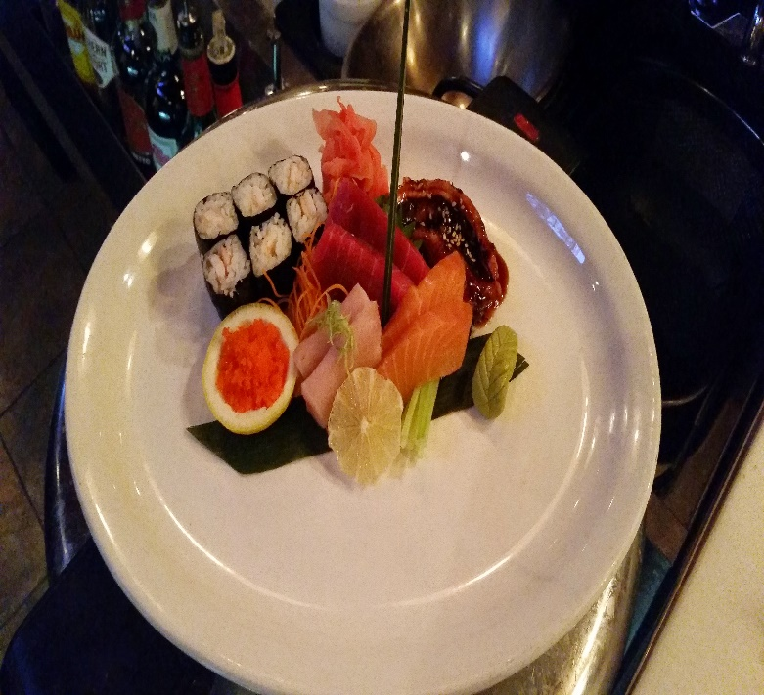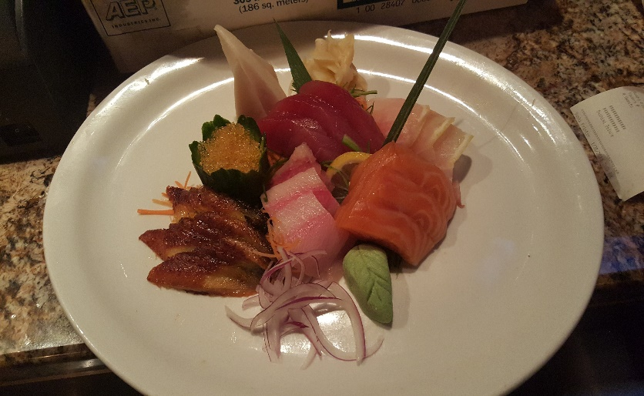The reason that I bring in this topic is I had nearly 8 years experience in making sushi. I started as a sushi helper in a restaurant in NYC early 2009. Base on my personal experience, I found more and more Americans eating sushi as their health diet. The enormous demand leads the industry to expand so quickly. Every year, we will see a lot new Japanese restaurant opening or the old place adding the sushi on their normal menu. Moreover, the chefs are creating more styles of it. They combine the ideas from Italy, French, Chinese into the tradition way to make sushi.

